Agenda-Display all managers who are working for the “Sales” division and have a minimum of 5 employees reporting to them

Create a sub report in Data-Admin-Operator-ID class

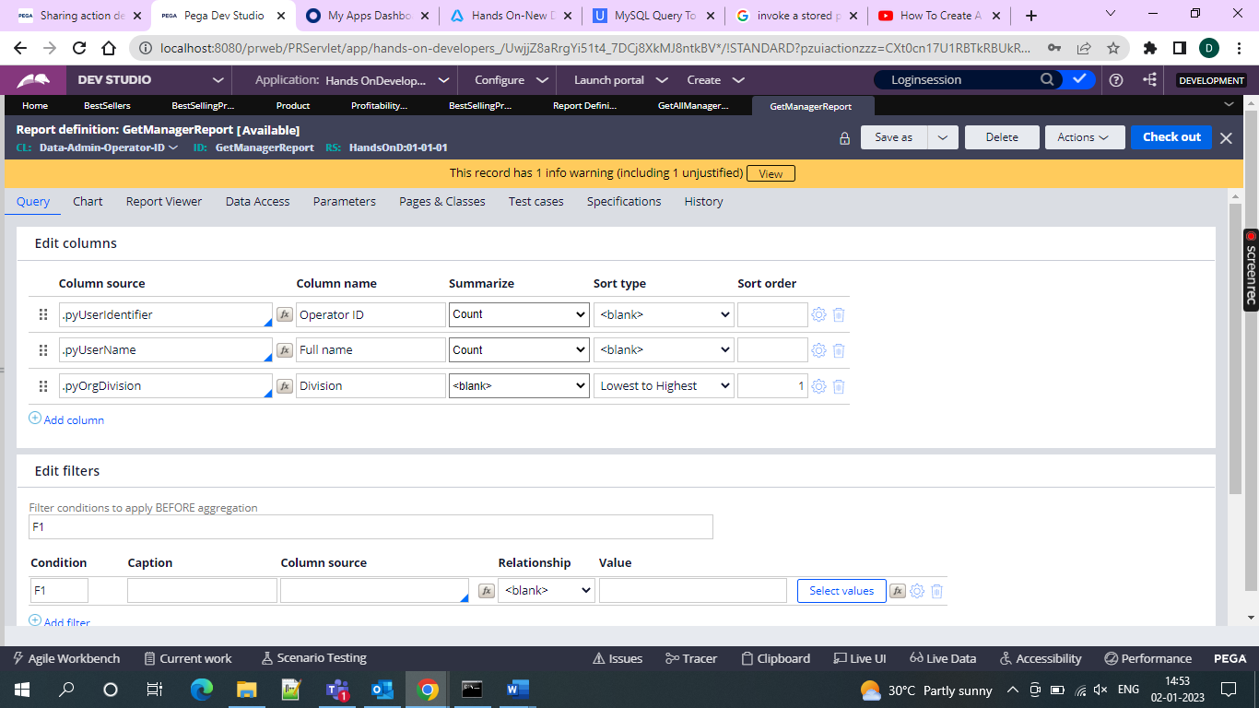

And then include this in the main report configure as below

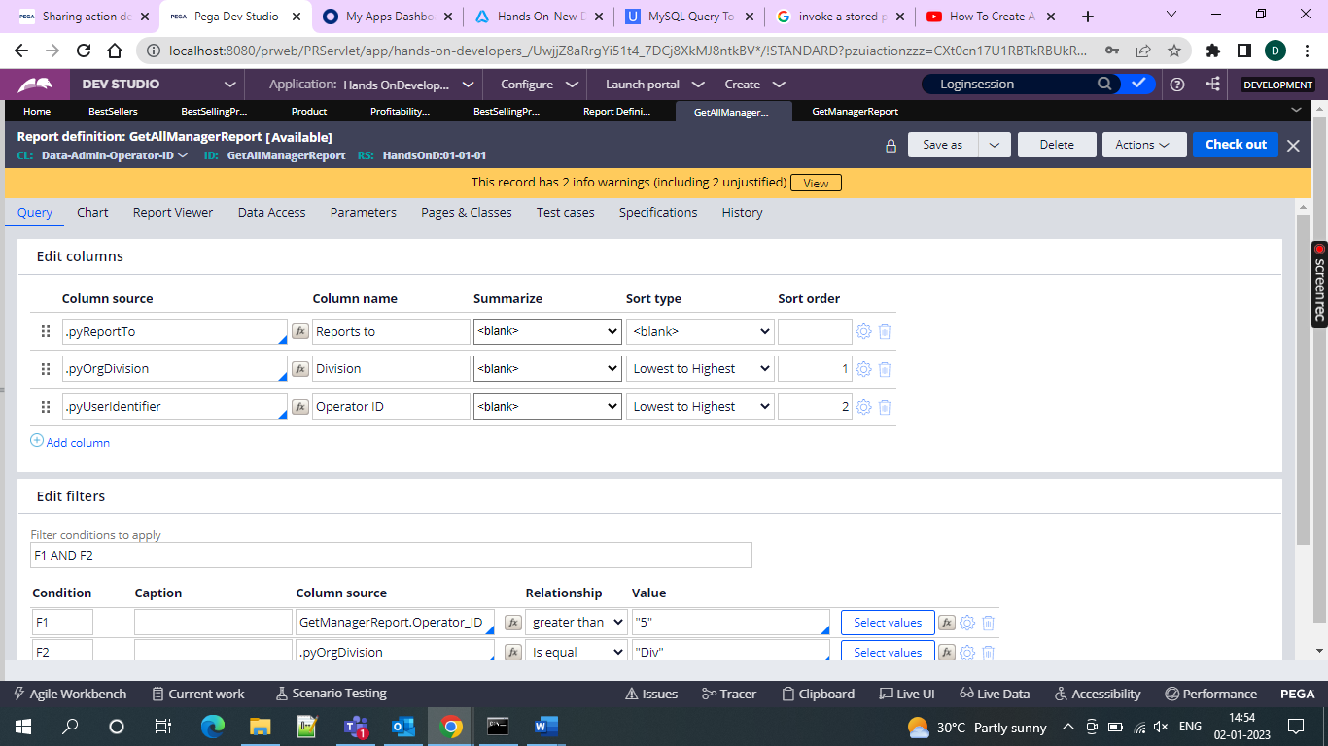

And then add the filters upto 5 operators and include your division and then add the division in my case it is div